
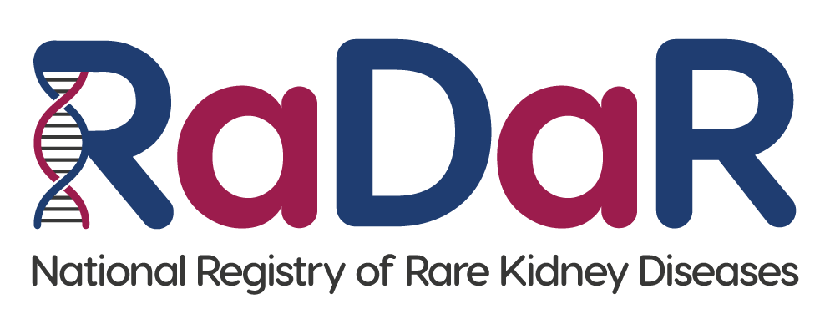
Child Patient Information Sheet (Age 6-11)

To be shown and read by parent/guardian if required

We would like to invite you to take part in our research. This leaflet will help you to decide if you would like to say yes or no.


1. What is research?
Research is something we do to find the answers to important questions. We want to answer questions about rare kidney diseases.

2. What does rare kidney disease mean?
If you have a kidney disease it means your kidneys might not work the way they should. This can make you feel very poorly. A rare disease is one that not many people have.
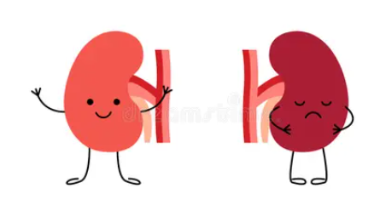
Healthy Kidney
Poorly Kidney

3. What is RaDaR?

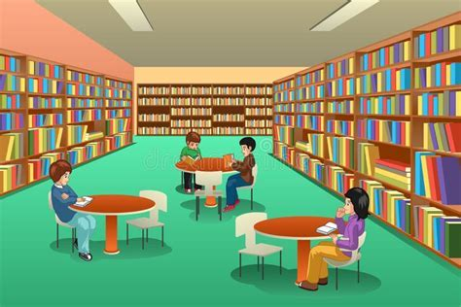
RaDaR is the name of a big collection of information (a little bit like a library) about children and grownups who have a rare kidney condition.

Having all this information together helps everyone to answer questions about what causes kidneys to stop working properly and how to help make people feel better.

4. What will happen if I want to take part?



If you want to take part, you won’t need to do anything extra, and your doctor will carry on looking after you as normal.

Someone that works in the hospital will add information about you, your kidneys and your treatment into RaDaR using a computer.

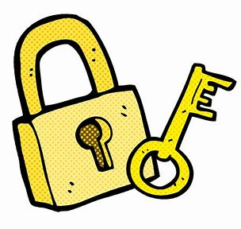

5. Will my information be kept safe?
Information about you and your kidney disease is very special and we promise to look after it carefully.


6. What if I don’t want to take part?
That is OK! You don’t have to take part if you don’t want to.

7. What if I say yes and then change my mind?
That’s Ok too! Just tell your mum, dad, carer, doctor or nurse at any time. They will not be cross with you and you don’t have to give a reason.


8. What if I’m still not sure?
If you have some questions about RaDaR you can talk about it with your family or your doctor.

Thank you for taking the time to read this.

